Twelve New Jersey high school and middle school students were the winners of the New Jersey Department of Human Services (DHS) New Jersey Teen Media Contest in 2023. The contest helps the New Jersey Department of Human Services, Division of Family Development, reinforce its mission to instill a sense of parental responsibility in New Jersey's youth.

Students were honored for their winning entries, which celebrated the students’ artistic or written portrayal of the theme – how their parents or loved ones make everyday things special and/or what those adults do to celebrate these small milestones and achievements.

The contest was open to all New Jersey high school and middle school students.

1st Place – High School -- Artwork
Gabriella Freeman
Piscataway High School
Game Night
Teacher: Dorothy Amme

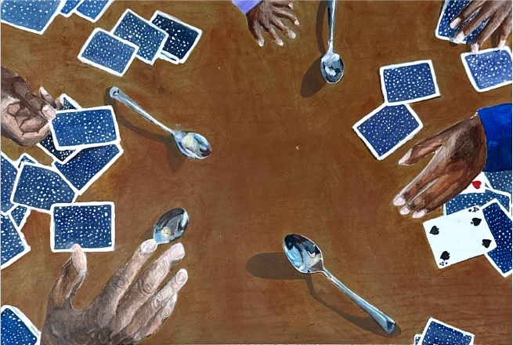

2nd Place – High School – Artwork
Sophie Drechsler
Monmouth County Academy of Allied Health and Science
Mama
Teacher: Ms. Pitman

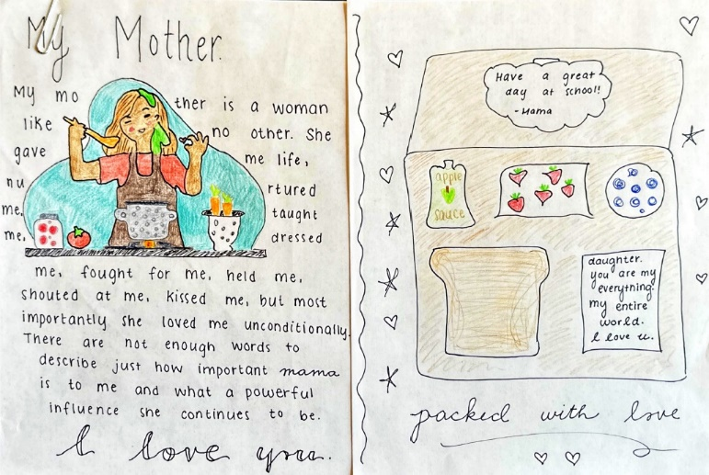

3rd Place – High School -- Artwork
Katherine Gomez
Frank J. Cicarell Academy
Cooked with Love

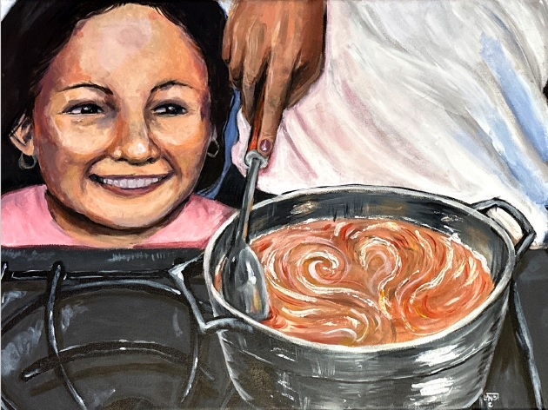

1st Place – Middle School – Artwork
Sadie Bober
Memorial Middle School
Every Step of the Way
Teacher: Lynn Thompson

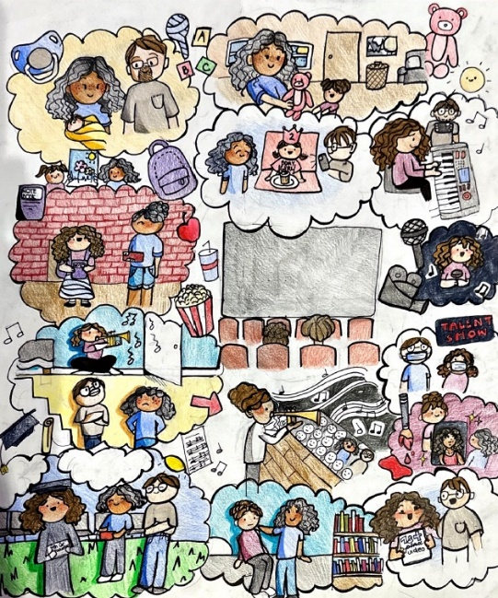

2nd Place – Middle School – Artwork
Liam Wong
Academy 1 Middle School
Capturing Moments
Teacher: Martha Garcia

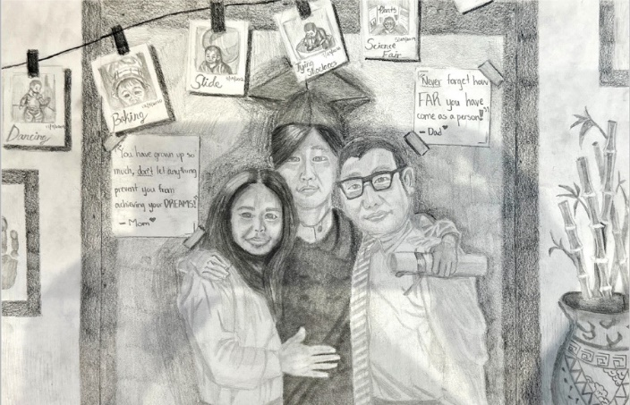

3rd Place – Middle School – Artwork
Yuna Lee
Benjamin Franklin Middle School
4 Feet & 5 Inches
Teacher: Ms. Fontan

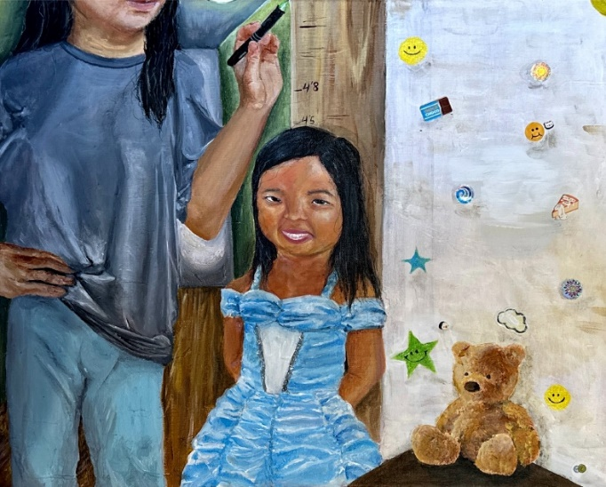

1st Place – High School – Written Word
Chloe Care
Ocean City High School
While Under Two Roofs
Teacher: Mrs. Cunningham

While Under Two Roofs

All under two roofs
My parents have always celebrated me through my smallest achievements
and my greatest accomplishments

All under two roofs
My parents display their excitement for my daily fulfillments and congratulate my hard work, even if it can mean nothing to someone else

All under two roofs
My parents express their affection through cooking my favorite dinner,
or baking me my favorite cookies

All under two roofs
My parents communicate their terms of endearment through thoughtful texts
or placing hand written notes in my lunch

All under two roofs
My parents exclaim their words of encouragement to show they believe in me each day

While we may not live under the same roof, each parent has given me a foundation of love; for the heart of a home is not always within four walls and a roof, it goes where you go.

2nd Place – High School – Written Word
Brooke Liebrand
Ocean City High School
Parenting
Teacher: Mrs. Cunningham

Parenting

Somewhere between the beginning and now,
It went from "Thanks for embarrassing me on my birthday mom"
To "Thank you for making my day special"

Somewhere between the beginning and now,
It went from "Dad, you can't come shopping, it's a girls thing"
To "Thank you for being so involved dad"

Somewhere between the beginning and now,
It went from "Mom, it's not a big deal, I always get good grades"
To "Thank you for always celebrating my hard work"

They made sure I had candles to blow out on my birthday,
Even on days it felt I didn't deserve to be celebrated.
They worked relentlessly
To give me the praise I didn't know I needed.

From temper tantrums to teenage fights,
They hug me when I feel small,
Yet cheer the loudest when I stand tall.

Somewhere between the beginning and now,
I realized the other half of my heart belonged to the people
who nurtured it in the first place.

3rd Place – High School – Written Word
Abigail Hays
Ocean City High School
Dude, I’m So Proud of You
Teacher: Mrs. Cunningham

Dude, I’m So Proud of You

"Dude, I'm so proud of you."
The words I strive to hear.
Every practice, every test,
Competing in the biggest meet of the year,
Those words sit in the back of my mind.

A seemingly insignificant gesture,
With the most approving smile.
I could get an A on a quiz,
Or swim 32 miles.
Those words are better than any trophy in my hands.

If you take away my ribbons
And leave me with no medals,
To keep my going every day,
That phrase is still the only thing that's essential
Because dude, they're so proud of me.

1st Place – Middle School – Written Word
Ruqaiyah Hagigal
Pillars Preparatory Academy
My First Best Friend
Teacher: Rida Ahmed

My First Best Friend

I feel ecstatic in her presence, though I also feel dramatic in her absence
Whenever we bond, my happiness goes beyond
When she smiles at me, my face lights up in glee
Though, whenever I have a bad day, she detects my smile that fades away
My mom is honestly my best friend, our bond can never end
Whenever I feel lonely, she's the only one to comfort me
When I accomplish something big, she takes me out to ice cream
Whenever I lose my soccer game, she still makes me feel like a winner
I love whenever I achieve something, if it’s big or small, she makes me feel like a victor
In my eyes, she’s my number one best friend, she’s my home, my warmth
Whenever I’m frustrated, she always finds a way to put a smile on my face
I love when I talk about school, she’s always invested in the conversation
Every year she makes my birthday feel special, even if the birthday was big or small
I love how we can rely on each other
I’m never going to forget how much you’ve done for me
I love how even though she had a long day at work, she still tries to help me with my homework
I appreciate that even though it’s cold outside she’s still there for me during my soccer game
In other eyes, shes my mother
Though, in my eyes she’s my first best friend

2nd Place – Middle School – Written Word
Avery Dravis
Memorial Middle School
The Power of Family
Teacher: Lynn Thompson

The Power of Family

There are things that I will never forget,
No matter how old I grow,
No matter the moments of sorrow I may show,
Sitting, at the table with conversations that produce laughs,
Running, to the ice cream truck while stomping through the grass,
The fun that we had once long ago,
It turns into rememberings that stay and will never let go.

The nights of all the late kitchen table talks
Suddenly turn into unforgettable memories that won't ever make me feel awk
Dazing into the warm-hearted spirit of each conversation
Sending my head into a whirl of loving representation
Never forgetting
Never Ever

Each day there are special thoughts
And important things that are taught
Like how to choose the right path
And always remember to make others laugh
Make sure to say goodnight before bed
And try to be the one who has led
The actions being said will always lead you to equitable decisions.

Making special those songs in the car
And those dark summer nights when we look up to the stars
Fires and s’mores while out in the back
Trips to the Keys and eating Moose Tracks
Playing board games on the long rainy nights
Sitting on the steps to settle our fights
Each different memory includes a piece
A piece of my heart that I will cherish for long

Some of these moments change with the seasons
They're special to me for a variety of reasons
Summer days on the boat with the wind in my hair
Winter sleds on the hill without a care
Autumn breezes that blow leaves in my face
Planting Spring flowers all over the place
As a family, we share moments throughout the seasons
Creating stories to share when the time comes

Music gliding through our cars
Concerts, Radio, and Karaoke appear
The stories told through each lyric and note
Gives us breaths and peace from the person that wrote
Songs make us happy and fill us with glee
Oh how we love each memory
These artists share stories with the whole world
Bringing positive moments to all

The power and magnificence of families coming all together
Sharing the magnificence of one another
During sad days
Mad days
Rad Days
The support is immense and incredible
All these memories and times could never be replaced.

3rd Place – Middle School – Written Word
Eila Moran
Bernardsville Middle School
How Even the Smallest Things Can Make a Huge Difference
Teacher: Patricia McMillan

How Even The Smallest Things
Can Make a Huge Difference
What are some things that parents and loved ones do every day to make life
special for you? Parents and loved ones can make every day special in many ways. I
can’t even count how many things my family does to make every day special, but one
way my parents and loved ones make every day special is by just being there for me
when I need them. Another way is encouraging me and helping me to be the best me
that I can be.

My family is always there for me when I need them even if I’m upset about
something small, like messing up in a lacrosse or field hockey game. If I am upset, they
make me feel better; for example, when I didn’t play great in a field hockey game or I
felt like no one would pass to me at lacrosse, they would make me feel better. When my
cat passed away, I was really upset because he used to come up to my room and lie on
my pillow while I read and he would nudge the corner of my book so that I would pet
him, and it was really nice; they made me feel better even though I was really upset.
Thanks to my family, we started looking at pictures of Eero and laughed when we found
a picture of him sticking his tongue out in the photo. So even if it's something small, my
family is always there for me no matter what, and even just knowing that they are there
for me makes me feel better.

My family helps me in many aspects of school, but they also help and encourage
me to be the best me that I can be. They encourage me to always do extra credit if I
have the option to or go above and beyond and not just do the bare minimum.
Sometimes it's nice to have the reminder to always go above and beyond or do extra
credit if I have the option because sometimes I don’t want to. Sometimes having
someone reminding you of all the stuff you should do can be annoying, but it can also
be helpful and nice. Somedays I just want to sit down and do nothing even if I have
something to do, and that's when it's really nice to have something there to encourage
you to finish your task and then relax. If my family didn’t always remind me to do extra
credit or just finish a little extra of something, I might not always choose to.

In conclusion, my family makes every day special for me by just being there for
me and encouraging me to be the best me that I can be and to make the best out of my
day. Sometimes even just the smallest things can make a huge difference in your
everyday life. So, when you are wondering what your parents do for you every day think
about the little stuff, because sometimes that's what makes a difference.

